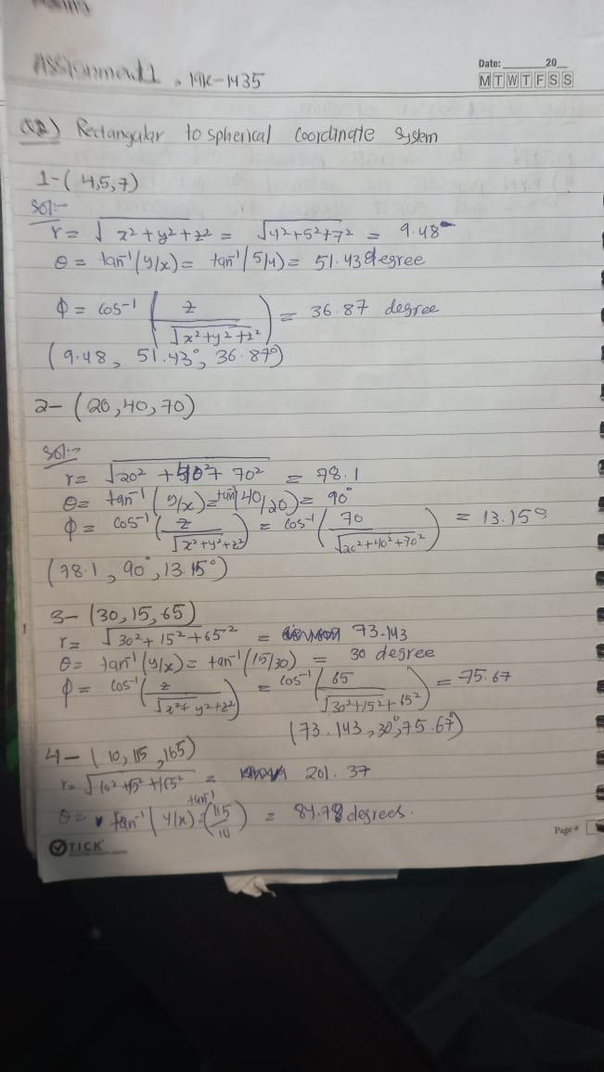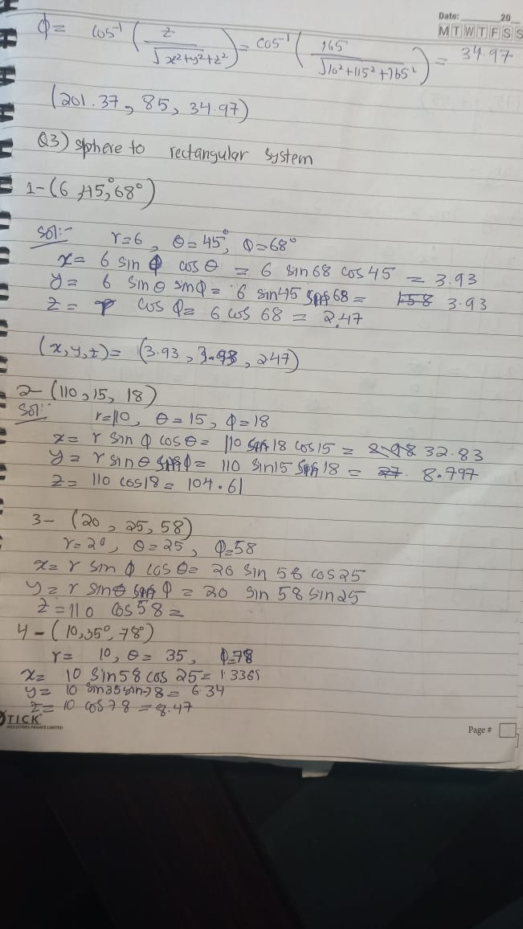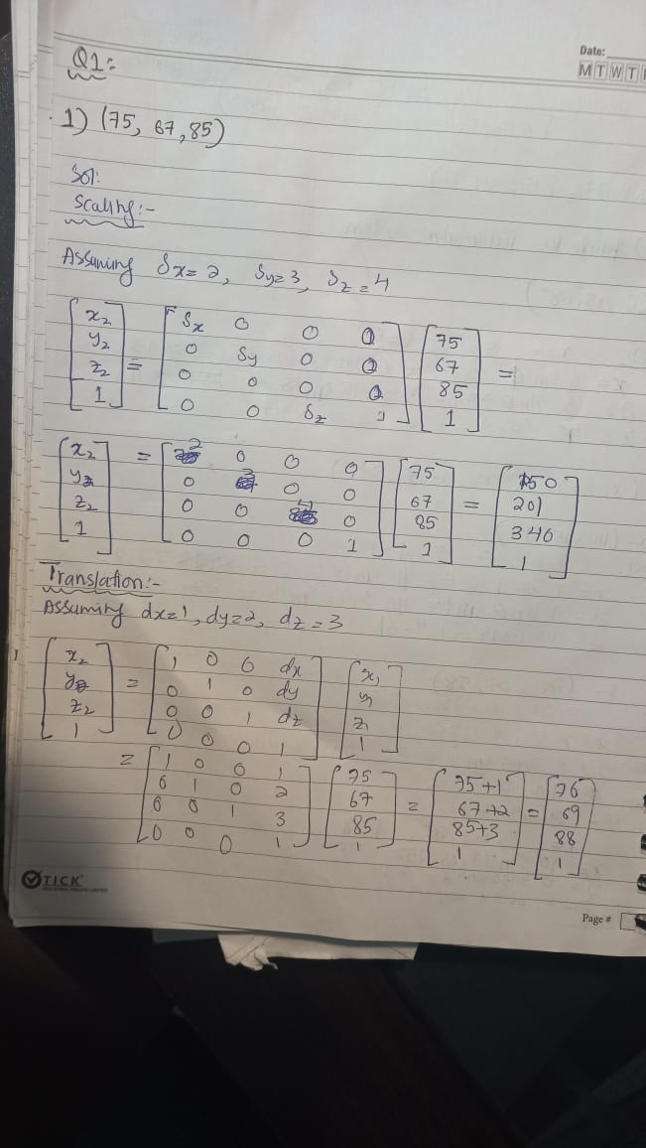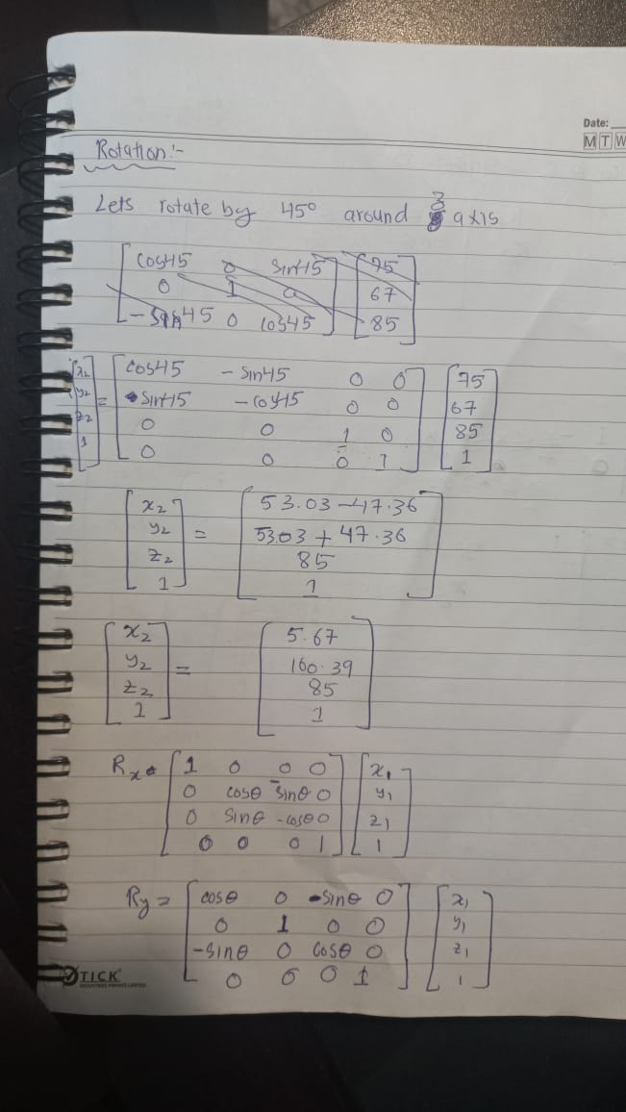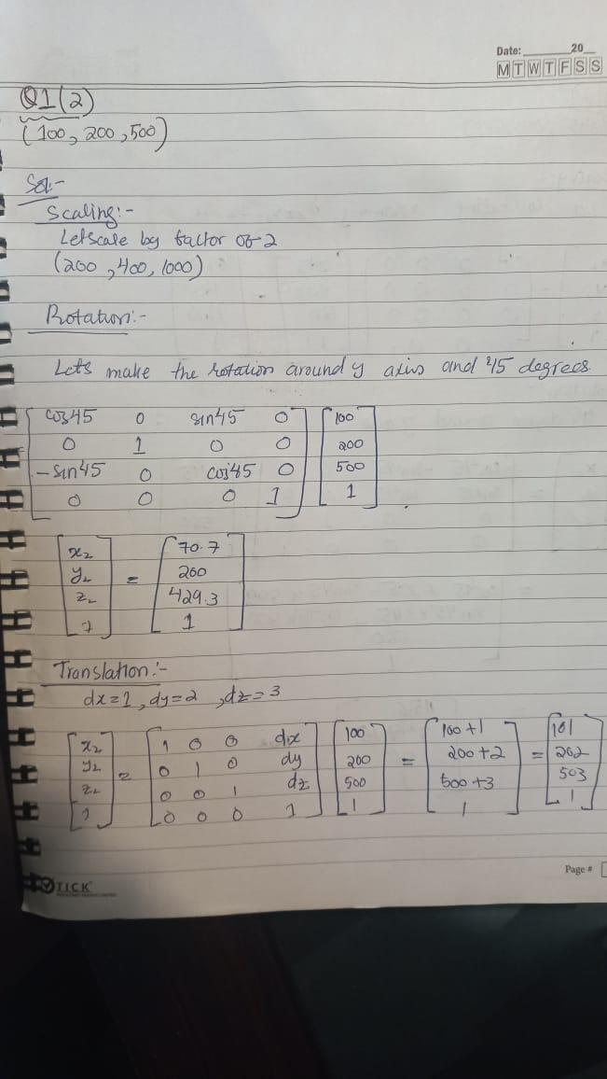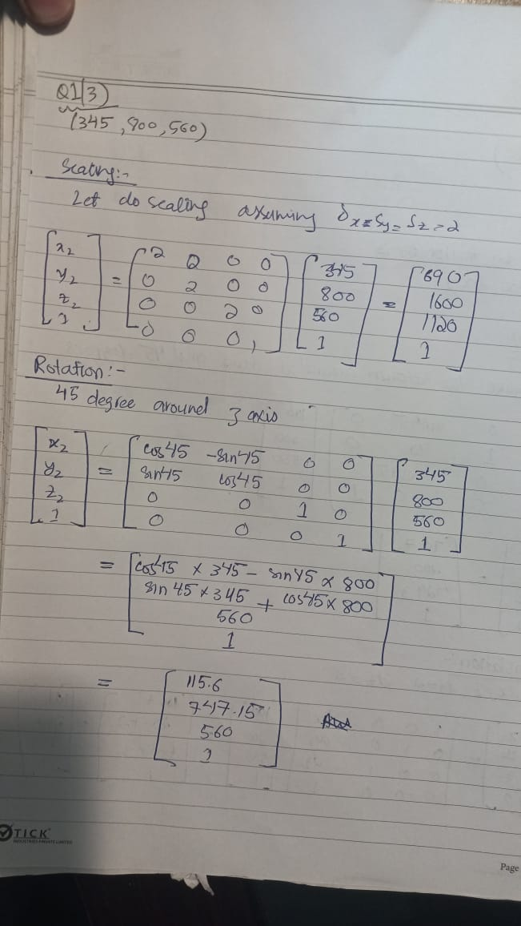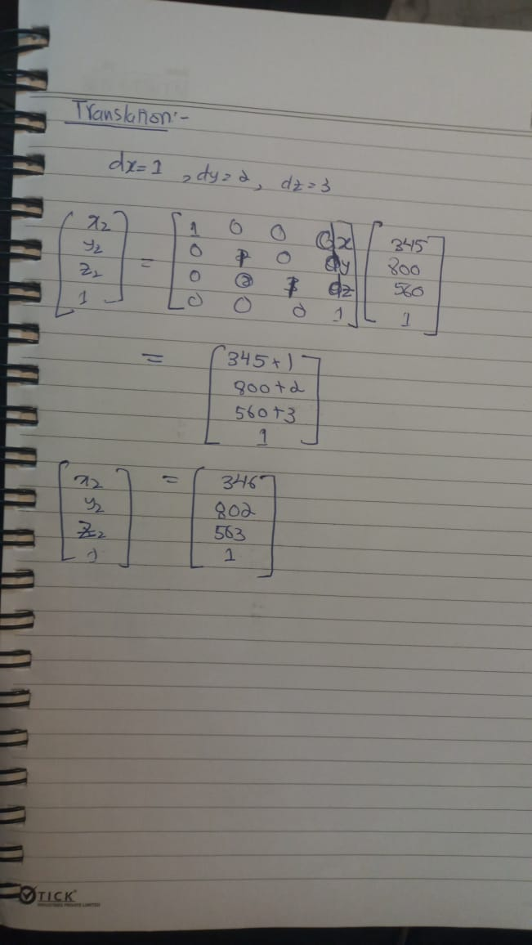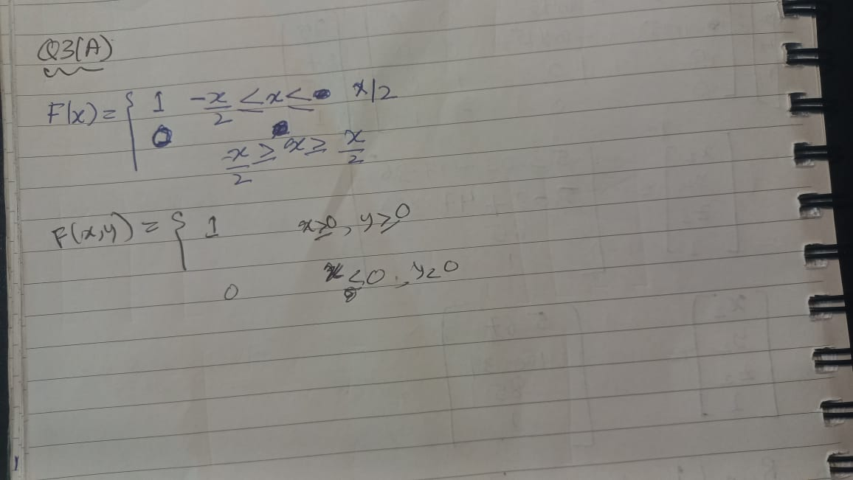

***Q4:***

MNIST is short for Modified National Institute of Standards and Technology database.

MNIST set is a large collection of handwritten digits. It is a very popular dataset in the field of image processing. MNIST contains a collection of 70,000, 28 x 28 images of handwritten digits from 0 to 9. The dataset is divided into training and testing sets.  There are 60k images in the training set and 10k images in the testing set.

The dimension of our training vector is (60000, 28, 28), this is because there are 60,000 grayscale images with the dimension 28X28.

Here is the link where EDA has been performed

<https://jovian.com/ammarullahkhan5/fcv-assignment/v/5>

Q5: